Data Mining II

Quiz 2

1. **Briefly** describe **a scenario** when Generalized Association Rules would be preferable to the apriori algorithm.

When dealing with a huge dataset and calculating support is computationally expensive. Apriori algorithm can be used for low cardinality thinly scattered transaction database. Judgement in Generalized Association Rules can be used to trim out the candidate item sets that have zero scope to be huge. This is when a large dataset with rate items is taken in consideration where its support is set too high. This is when it becomes very expensive to compute the rules and also to find the rare item. Also for example, to increase the sales of the store we can use the Generalized Association Rules. The algorithm can be used to find the set of items that are associated with each other. If they are present closed then they should be chosen together for buying the store. Using Generalized Association Rules in this case is preferred.

1. Consider the following transactions (tomato, beer, rice, chicken, baby bottles, pears) :

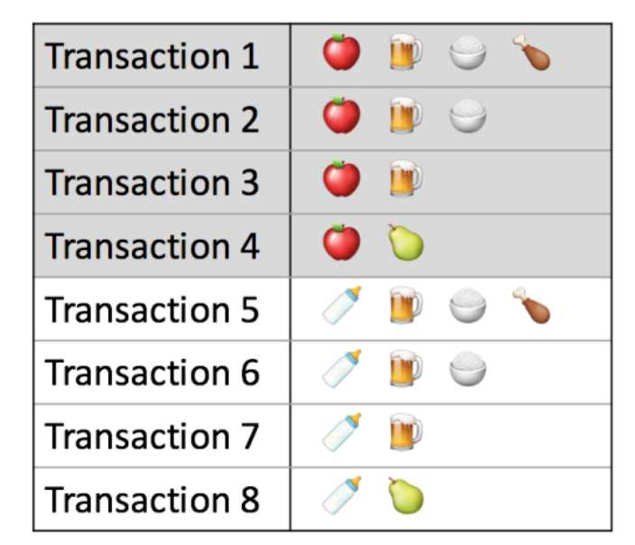

1. Identify item baskets with of size 3 with the highest support.

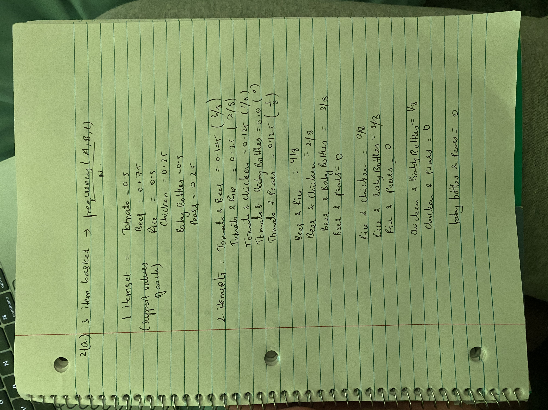

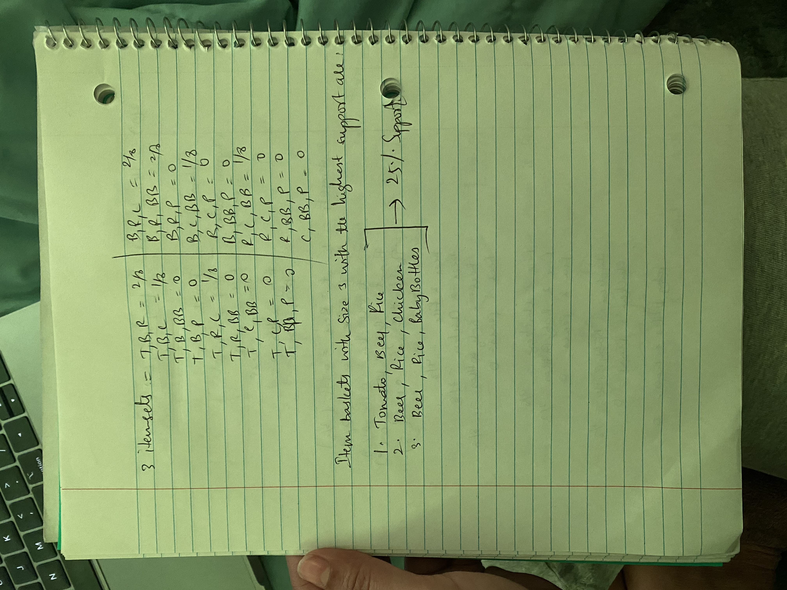

b) Find an association rule with three items that has the highest lift.

